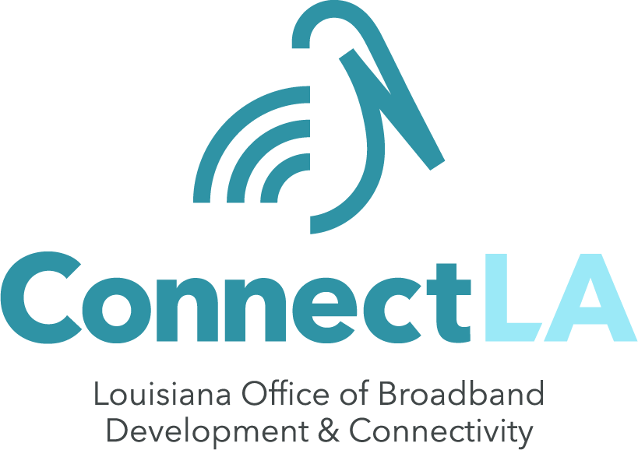
Media Coverage
AUGUST 26, 2024
The Daily Star: Mizell lauds rural broadband access
As Governor Jeff Landry announced the launch of GUMBO 2.0, longtime champion of rural broadband State Senator Beth Mizell discusses the far-reaching impact that the program will have on Louisiana.
AUGUST 27, 2024
WGNO: Shreveport airport upgrades, expanded rural broadband wins for Louisiana; Cassidy says
Senator Bill Cassidy visited Shreveport to share updates on the GUMBO 2.0 program, which will put into action a $13.5 billion investment.
KSLA: Sen Bill Cassidy talks Gumbo 2.0, airport funding & more
Senator Bill Cassidy discusses the GUMBO 2.0 program, its impact, and the importance of broadband access in Louisiana.
KSLA: Sen. Bill Cassidy speaks to Bossier Chamber of Commerce
Senator Bill Cassidy speaks to the Bossier Chamber of Commerce about the future of broadband in Louisiana with the GUMBO 2.0 program.
AUGUST 28 ,2024
The Jena Times: LaSalle Students Attend Governor’s Event
An administrator and students from a school in LaSalle Parish, which received GUMBO 1.0 funding, attend Governor Jeff Landry’s press conference to announce the launch of GUMBO 2.0.

KNOE: U.S. Senator Bill Cassidy visits Monroe to discuss business, environmental care
Senator Bill Cassidy visits Monroe to discuss the future of Louisiana, including the roll-out of the GUMBO 2.0 program, which will distribute $1.35 billion to give all Louisianians access to high-speed internet.
Telecompetitor: Louisiana Broadband Director Details Route to Nation’s First BEAD Awards
As the first round of applications for GUMBO 2.0 launches, the state of Louisiana expects to be the first to award BEAD funding, aiming to announce awards by November 1.

